**ER Diagram for Property Renting/Selling**

# **User Service**

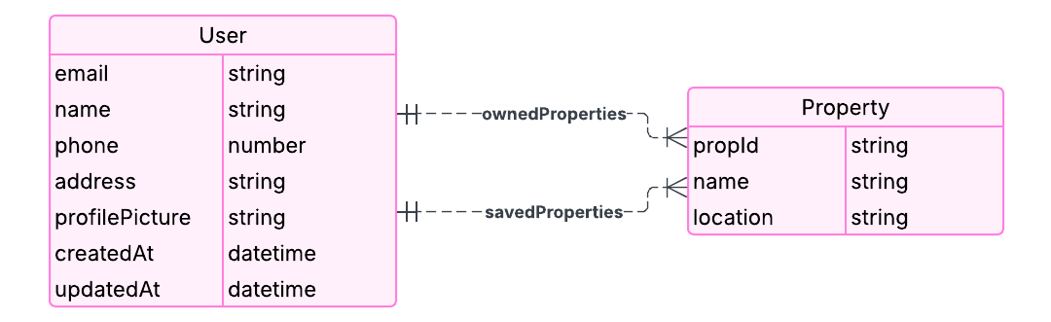

# **Booking Service**

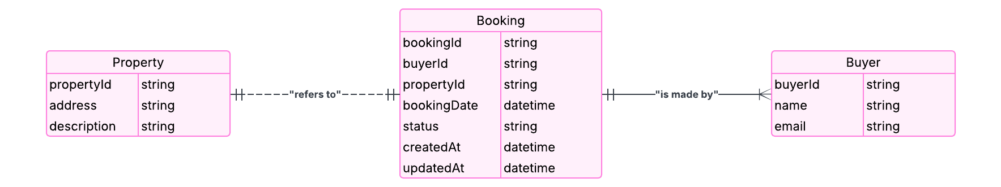

# **Authentication Service**

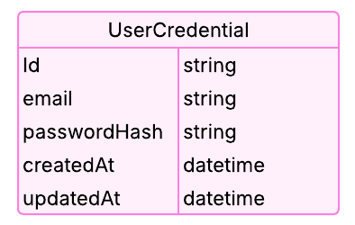

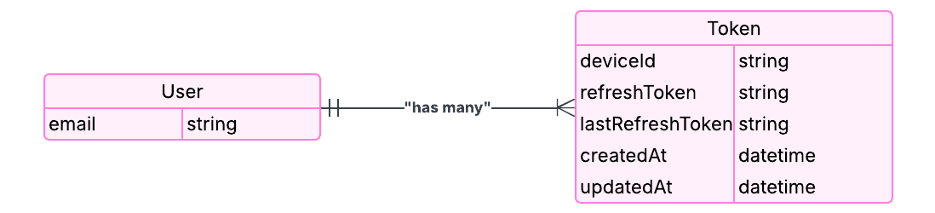

# **Property Service**

